Database Development and Class Registration

Shanae Revell
The University of Arizona Global Campus
CST499: Capstone for Computer Software Technology
Charmelia Butler
February 23rd 2026

Database Development and Class Registration
The development phase of a software project is where system designs and requirements are transformed into a functional application. In Week 3, the foundational components of the class registration system were successfully implemented, including user authentication, database connectivity, and form validation. Instructor feedback confirmed that the project demonstrated strong technical execution, effective use of CRUD operations, and a logical user workflow. Building on that foundation, Week 4 focused on completing the remaining functionality required for a full class registration system. The purpose of this paper is to document the continued development of the application, including database table creation, backend integration, class registration, schedule management, and a reflection on the implementation experience.
Based on the feedback received in Week 3, no major revisions were required. The MySQL database and tables were accurately created, the front-end pages were properly connected to the backend, and the registration workflow functioned as intended. The project already demonstrated effective form validation, error handling, and dynamic updates. As a result, my Week 4 development focused on extending existing functionality rather than correcting errors. The established database connection class and session-based authentication logic were reused to maintain consistency and ensure secure access across new application pages.
To support class registration and schedule management, I created two additional tables within the MySQL database: courses and registrations. The courses table serves as a catalog of available classes and includes attributes such as course code, course name, course credit amount, and the academic term. The registrations table links users to the courses they have registered for. This table includes foreign keys referencing both the users and courses tables, ensuring referential integrity and supporting many-to-many relationships.
Primary keys, foreign keys, and a unique constraint were implemented to prevent duplicate course registrations for the same user. I took screenshots of the database structure and tables to document the successful creation of these components. Additional screenshots demonstrate the database state before and after each key operation, including course registration and deletion, verifying that data was inserted and removed correctly.
The application pages were connected to the backend database using PHP and a reusable database connection class. Several new pages were developed to support the remaining system requirements. The course catalog page displays all available courses retrieved from the database and allows logged-in users to register for classes. When a user selects a course, the application inserts a new record into the registrations table using prepared statements to ensure secure database interaction.
The “My Classes” page lists all courses the logged-in user is currently registered for. This page retrieves data using a SQL JOIN between the registrations and courses tables, allowing course details to be displayed clearly and accurately. A delete option was implemented on this page to allow users to remove courses from their schedule. When a course is dropped, the corresponding record is deleted from the database, and the updated schedule is displayed immediately.
The class registration functionality allows users to enroll in available courses while preventing duplicate registrations. Once a course is registered, it appears immediately on the user’s schedule, demonstrating dynamic application behavior. Users can add multiple courses to their semester by returning to the course catalog and registering for additional classes. The schedule management feature allows users to delete courses they no longer wish to take. This action removes the corresponding record from the database and updates the displayed schedule in real time. Screenshots were captured to show the system before and after course deletion, both in the application interface and within the database. These features collectively demonstrate a complete implementation of operations and reinforce the importance of backend validation and data integrity.
The implementation phase highlighted the importance of building on a strong foundation. Because the database connection, authentication, and basic structure were correctly implemented, extending the system in Week 4 was a smooth process. Creating the additional tables reinforced concepts related to relational database design and many-to-many relationships. Developing the registration and schedule management features strengthened my understanding of database building. Testing each feature and validating changes through both the user interface and phpMyAdmin reinforced the importance of verification during development. Seeing immediate updates in the database after each action provided clear confirmation that the system was functioning correctly. Overall, this phase improved confidence in developing database-driven web applications and managing end-to-end system behavior.
I completed the week 4 assignment by implementing database tables, backend integration, and full schedule management functionality for the class registration system. By building on the strong foundation established in Week 3 and incorporating instructor feedback, the application now supports registering for classes, viewing a personalized schedule, adding additional courses, and deleting classes from a semester plan. The project demonstrates effective use of MySQL, PHP, relational database design, and CRUD operations. This implementation reflects a solid understanding of database-driven application development and reinforces key software engineering principles related to design, integration, and testing.

Screenshots
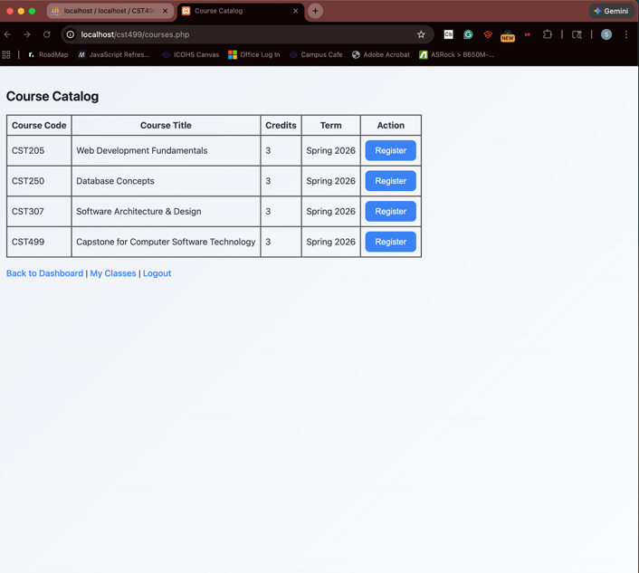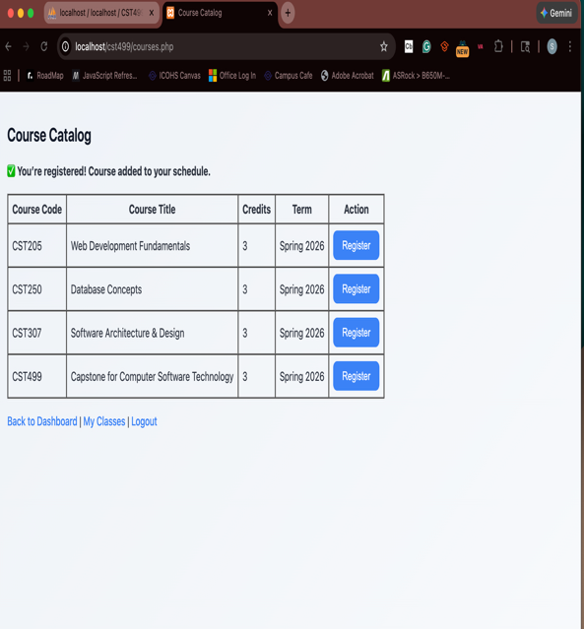
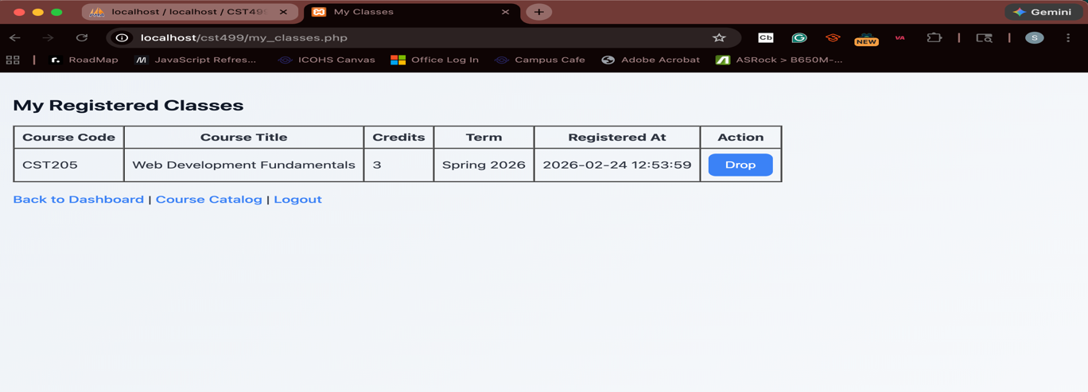

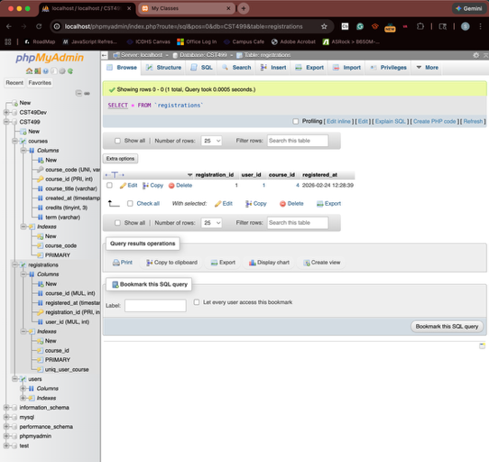

References
PHP Manual. (2024). MySQLi extension. https://www.php.net/manual/en/book.mysqli.php
Silberschatz, A., Korth, H. F., & Sudarshan, S. (2020). Database system concepts (7th ed.). McGraw-Hill Education.
Tsui, F., Karam, O., & Bernal, B. (2018). Essentials of software engineering (4th ed.). Jones & Bartlett Learning.

